Strings

String is a collection of characters and these characters can be alphabets, digits or special characters.
String is an immutable sequence data type. After creating string changes cannot done. String does not provide the following operations.
- append()
- insert()
- remove()
- pop()
- del
- extend()
- sort()
- replacing
“str” class or data type is used for representing string object.
String is non numeric data type and we cannot perform arithmetic operations.

How to create string or representing string?
String can be created in different ways
- within single quotes
- within double quotes
- within triple single quotes or double quotes
- str() datatype or function

Example:
str1='python'
str2="python"
str3='python "programming" language'
str4="python 'programming' language"
str5='''python
programming
language'''
str6="""python
programming
language"""
print(str1,str2,str3,str4,str5,str6,sep="\n")
str7='python \'programming\' language'
str8="python \"programming\" language"
print(str7,str8,sep="\n")

Output
python
python
python "programming" language
python 'programming' language
python
programming
language
python
programming
language
python 'programming' language
python "programming" language

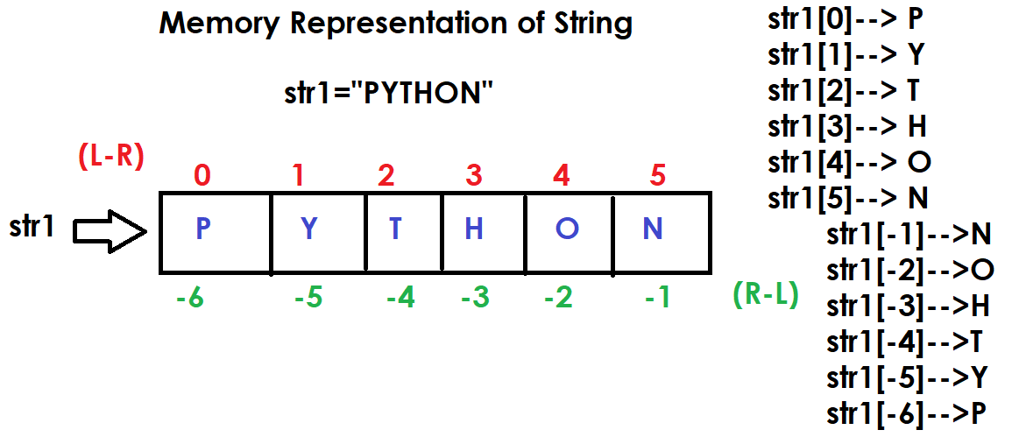
>>> str1="PYTHON"
>>> print(str1)
PYTHON
>>> str1[0]="J"
Traceback (most recent call last):
File "<pyshell#2>", line 1, in <module>
str1[0]="J"
TypeError: 'str' object does not support item assignment
>>> del str1[0]
Traceback (most recent call last):
File "<pyshell#3>", line 1, in <module>
del str1[0]
TypeError: 'str' object doesn't support item deletion
>>> str1.append("A")
Traceback (most recent call last):
File "<pyshell#4>", line 1, in <module>
str1.append("A")
AttributeError: 'str' object has no attribute 'append'

How to read content of string?
The content of string can be read in different ways
- using index
- using slicing
- using for loop
- using iterator
- using enumerate

Example:
str1="programming"

# Using index
for i in range(len(str1)):
print(str1[i],end=' ')

#Using Slicing
print()
str2=str1[0:4]
print(str2)
str3=str1[::-1]
print(str3)
str4=str1[::2]
print(str4)
str5=str1[2:-2]
print(str5)
str6=str1[4:]
print(str6)

#Using for loop
for ch in str1:
print(ch,end=' ')
print()
for ch in str1[::-1]:
print(ch,end=' ')

Output
p r o g r a m m i n g
prog
gnimmargorp
pormig
ogrammi
ramming
p r o g r a m m i n g
g n i m m a r g o r p

Example:
# Write a program input string and count vowels

str1=input("Enter any String ")
count=0
for ch in str1:
if ch in "aeiousAEIOU":
count=count+1

print(f'String is {str1}')
print(f'Vowel Count is {count}')

Output
Enter any String apple
String is apple
Vowel Count is 2

Enter any String programming
String is programming
Vowel Count is 3

Example:
# Write a program to input string and count
# alphabets, digits and special characters

str1=input("Enter any string")
ac=0
dc=0
sc=0

for ch in str1:
if (ch>='A' and ch<='Z') or (ch>='a' and ch<='z'):
ac=ac+1
elif ch>='0' and ch<='9':
dc=dc+1
else:
sc=sc+1

print(f'Alphabet Count {ac}')
print(f'Digit Count {dc}')
print(f'Special Character Count {sc}')

Output
Enter any stringpython 3.14
Alphabet Count 6
Digit Count 3
Special Character Count 2

Example:
# Write a program to find input string palindrome or not

str1=input("Enter any string ")
str2=str1[::-1]
print(str1,str2)
if str1==str2:
print("String is Palindrome")
else:
print("String is not Palindrome")

Output
Enter any string madam
madam madam
String is Palindrome

Enter any string java
java avaj
String is not Palindrome

Example:
#Check Whether the String is Symmetrical or Palindrome
'''
A string is symmetrical if the first half matches the second
half (ignoring the middle character for odd-length strings).
A string is a palindrome if it reads the same forwards and backwards.
For example:

s = "amaama" -> symmetrical (ama matches ama) and palindrome.
s = "abcba" -> palindrome but not symmetrical (ab ≠ ba).
'''

s=input("Enter any String ")

if s==s[::-1]:
print("Palindrome")
else:
print("Not Palindrome")

if len(s)%2==0:
fh=s[0:len(s)//2]
sh=s[len(s)//2:]
if fh==sh:
print("Symmetrical")
else:
print("Not Symmetrical")
else:
fh=s[0:len(s)//2]
sh=s[len(s)//2+1:]
if fh==sh:
print("Symmetrical")
else:
print("Not Symmetrical")

Output
Enter any String khokho
Not Palindrome
Symmetrical

Enter any String abcab
Not Palindrome
Symmetrical

Enter any String bacba
Not Palindrome
Symmetrical

Example:
# Find Length of String in Python
# without using len() function

str1=input("Enter any string ")
c=0

for ch in str1:
c=c+1

print(f'String is {str1}')
print(f'Count or Length of String {c}')
print(f'Length of string is {len(str1)}')
Output
Enter any string java
String is java
Count or Length of String 4
Length of string is 4

